**CSC478**

**Final Project**

**Report**

Sungmin Kim(1541007)

Abram Beyer

Hyunyou Choi

Jongho Jin

Content

1. Install Relevant Packages and Initial Setup××××××××××××××××××××× 3

2. Load Data ×××××××××××××××××××××××××××××××××××××××××××××××××××××××××××××××××××××××× 4

**[1] Install Relevant Packages**

* *Geopy* : it makes easy for Python developers to create coordinates of addresses, cities, countries around the globe using third-party geocoders. For brevity, the way to install ‘geopy’ package is as follows.

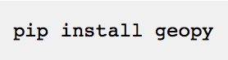

Here are brief tutorials of how to utilize ‘geopy’

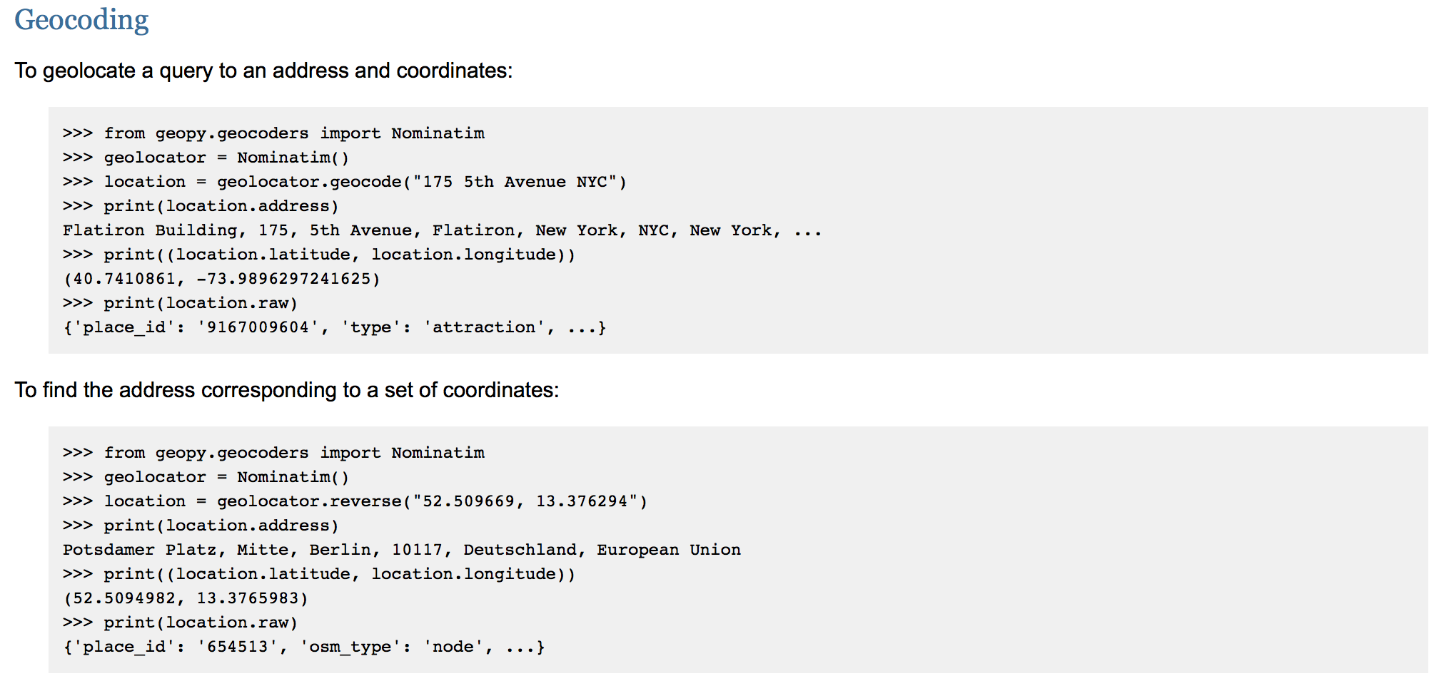

* For our project, we loaded all relevant packages such as Numpy, Pandas, Matplotlib, os, scikit_learn, etc.

**Initial Setup For The Group Project**

* For the convenience, our group created a github repository so that we can share our work at once.

**[2] Load Data**

* Data Source : <https://data.cityofchicago.org/Public-Safety/Crimes-2001-to-present/ijzp-q8t2>
* Initial Dataset Size : 6049608 rows, 22 columns